Experiment No. 3
[i] bubble sort :

#include <stdio.h>

int main() {
int arr[100], n, i, j, temp;

printf("Enter number of elements: ");
scanf("%d", &n);
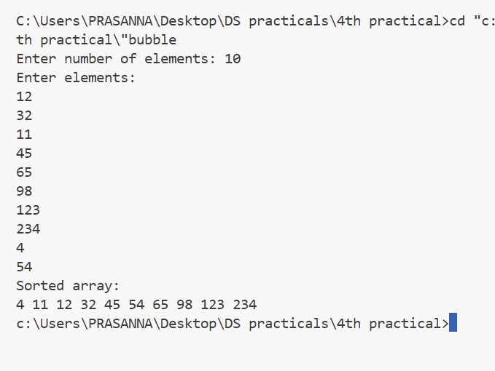
printf("Enter elements:\n");
for(i = 0; i < n; i++)
scanf("%d", &arr[i]);

for(i = 0; i < n-1; i++) {
for(j = 0; j < n-i-1; j++) {
if(arr[j] > arr[j+1]) {
temp = arr[j];
arr[j] = arr[j+1];
arr[j+1] = temp;
}
}
}

printf("Sorted array:\n");
for(i = 0; i < n; i++)
printf("%d ", arr[i]);

return 0;
}

[ii] insertion :
#include <stdio.h>

int main() {
int arr[100], n, i, j, key;

printf("Enter number of elements: ");
scanf("%d", &n);

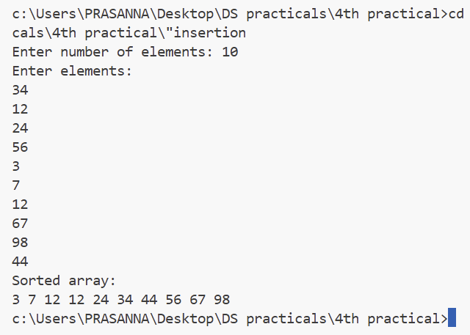
printf("Enter elements:\n");
for(i = 0; i < n; i++)
scanf("%d", &arr[i]);

for(i = 1; i < n; i++) {
key = arr[i];
j = i - 1;

while(j >= 0 && arr[j] > key) {
arr[j+1] = arr[j];
j--;
}

arr[j+1] = key;
}

printf("Sorted array:\n");
for(i = 0; i < n; i++)
printf("%d ", arr[i]);

return 0;
}

[iii] Merge :

#include <stdio.h>

void merge(int arr[], int l, int m, int r) {
int i, j, k;
int n1 = m - l + 1;
int n2 = r - m;

int L[50], R[50];

for(i = 0; i < n1; i++)
L[i] = arr[l + i];
for(j = 0; j < n2; j++)
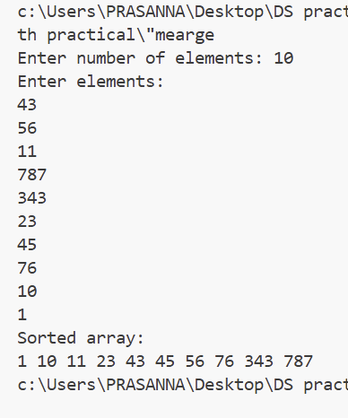
R[j] = arr[m + 1 + j];

i = 0; j = 0; k = l;

while(i < n1 && j < n2) {
if(L[i] <= R[j]) {
arr[k] = L[i];
i++;
} else {
arr[k] = R[j];
j++;
}
k++;
}

while(i < n1) {
arr[k] = L[i];
i++; k++;
}

while(j < n2) {
arr[k] = R[j];
j++; k++;
}
}

void mergesort(int arr[], int l, int r) {
if(l < r) {
int m = (l + r) / 2;

mergesort(arr, l, m);
mergesort(arr, m+1, r);
merge(arr, l, m, r);
}
}

int main() {
int arr[100], n, i;

printf("Enter number of elements: ");
scanf("%d",&n);

printf("Enter elements:\n");
for(i=0;i<n;i++)
scanf("%d",&arr[i]);

mergesort(arr,0,n-1);

printf("Sorted array:\n");
for(i=0;i<n;i++)
printf("%d ",arr[i]);

return 0;
}

[iv] quick :
#include <stdio.h>

void quicksort(int arr[], int low, int high) {
int i = low, j = high, pivot, temp;

pivot = arr[(low + high) / 2];

while(i <= j) {
while(arr[i] < pivot)
i++;

while(arr[j] > pivot)
j--;

if(i <= j) {
temp = arr[i];
arr[i] = arr[j];
arr[j] = temp;
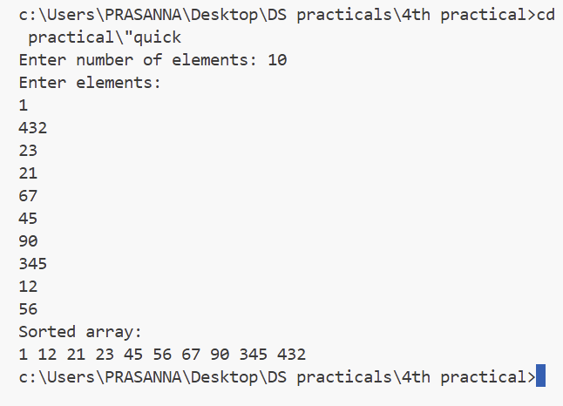
i++;
j--;
}
}

if(low < j)
quicksort(arr, low, j);
if(i < high)
quicksort(arr, i, high);
}

int main() {
int arr[100], n, i;

printf("Enter number of elements: ");
scanf("%d",&n);

printf("Enter elements:\n");
for(i=0;i<n;i++)
scanf("%d",&arr[i]);

quicksort(arr,0,n-1);

printf("Sorted array:\n");
for(i=0;i<n;i++)
printf("%d ",arr[i]);

return 0;
}
[v] selection :

//Prasanna Pradeep Bhurke
//Roll No. : 155

#include <stdio.h>

int main() {
int arr[100], n, i, j, min, temp;

printf("Enter number of elements: ");
scanf("%d", &n);

printf("Enter elements:\n");
for(i = 0; i < n; i++)
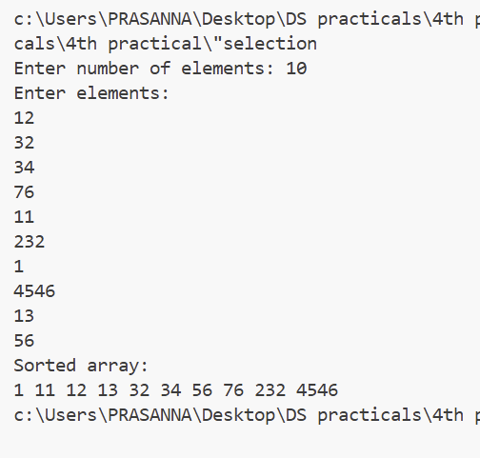
scanf("%d", &arr[i]);

for(i = 0; i < n-1; i++) {
min = i;
for(j = i+1; j < n; j++) {
if(arr[j] < arr[min])
min = j;
}

temp = arr[i];
arr[i] = arr[min];
arr[min] = temp;
}

printf("Sorted array:\n");
for(i = 0; i < n; i++)
printf("%d ", arr[i]);

return 0;
}

